**JAGAN INSTITUTE OF MANAGEMENT STUDIES**

SECTOR -05, ROHINI, NEW DELHI



**(AFFILIATED TO)**

**GURU GOBIND SINGH INDRAPRASTHA UNIVERSITY**

**SECTOR -16C, DWARKA, NEW DELHI**



**MINOR PROJECT ON RB APES**

**SUBMITTED TO: SUBMITTED BY: Raghav Babbar**

**Dr. MANJOT KAUR BHATIA Enrollment-no: 00150404421**

**Course: MCA -2nd Shift**

DECLARATION

I hereby declare that this project report entitled “RB APES”, **submitted to the Jagan Institute of Management Studies, Guru Gobind Singh Indraprastha University** in the partial fulfilment for the award of the Degree of **Master of Computer Application** is an authentic record of work done by me under the guidance of Dr Manjot Kaur Bhatia. The project has not previously formed the basis for the award of any other degree, Diploma, Associate ship, Fellowship or other title.

**RAGHAV BABBAR**

**MCA 2nd SEMESTER**

**00150404421**

CERTIFICATE

This is to certify that **Mr. RAGHAV BABBAR**, University Enrolment Number- **00150404421,** has worked under my supervision to prepare this project report of “RB APES”. The work embodied in this report is original and is of the standard expected of M.C.A student and has not been submitted in part or full to this or any university for the award of any degree or diploma, He has completed all requirement of guidelines for research project and the work is fit for evaluation.

Date:

Place: Delhi Signature of Guide: Dr MANJOT KAUR BHATIA

ACKNOWLEDGEMENT

The project work in this report is an outcome of continual work and intellectual support from various sources. It is almost impossible to express adequately the debts owed to many persons who have been instrumental in imparting this work a successful status. It is however a matter of great pleasure to express our gratitude and appreciation to all those people who had helped in completion of this project.

I would like to take the opportunity to thank Dr MANJOT KAUR BHATIA for giving me an opportunity to work on this project, which not only has increased our awareness but also has taught us the importance of work, it is because of their guidance, constant encouragement and inspiration that I have been able to accomplish the task of completion this project.

I express our sincere thanks to our project mentor Dr MANJOT KAUR BHATIA a for their invaluable guidance and frequent suggestions during the course of the project. Their suggestions helped me to maintain a good quality of work. I express our deep gratitude to them.

I would also like to thank my project external examiner and all the people who provided me with the facilities being required and conductive conditions for my MCA PROJECT ON **RB APES.**

ABSTRACT

The non-fungible token industry has great prospects, so NFT marketplace development is a good idea. This market is expected to increase at a 35% annual rate over the forecast period from 2021 to 2026, reaching $147 billion.

NFT has already become a mainstream phenomenon. This tendency can be explained by the growing number of influencers involved, the emergence of new gaming communities, and the increasing demand for digital art.

There already are a lot of NFT marketplaces, so this niche can be quite challenging. However, with an experienced team on your side it’s possible to build a unique cost-effective platform to attract new users.

NFTs use block chain technology, much like crypto currencies. It is also true for non-fungible token marketplaces. As a result, all the block chain’s advantages apply to your digital platform for NFT sales. Let’s take a look at the main benefits.

TABLE OF CONTENT

|  |  |  |  |
| --- | --- | --- | --- |
| **S No** | | **Topic** | **Page No** |
| 1 | | Certificate | - |
| 2 | | Acknowledgements | - |
| 3 | | List of Tables | - |
| 4 | | List of Figures | - |
| 5 | | List of Abbreviations | - |
| 6 | | **Chapter-1: Introduction** | 1-2 |
|  | | 1.1 About Project  1.2 Objective  1.3 Scope  1.4 Features  1.5 Need of the System  1.6 Limitation of Existing System |  |
| 7 | | **Chapter-2: Requirements and Analysis** | 3-6 |
|  | | 2.1 Introduction  2.2 Software requirement Specification  2.3 Functional Requirement of the Project  2.4 Hardware Requirements  2.5 Software Requirements  2.6 Technologies used  2.7 Use Case Diagram |  |
| 8 | **Chapter-3: Software Design** | 7-12 |
|  | 3.1 Introduction  3.2 Module Description   * 1. Data Flow Diagram (DFD)      1. 0-Level      2. 1-Level      3. 2-Level |  |
| 9 | **Chapter-4: Testing** | 13-15 |
|  | 4.1 Introduction  4.2 Test Plan  4.3 Conclusions |  |
| 10 | **Chapter-5: Roles and Responsibilities** | 16 |
| 11 | **Chapter-6: Conclusion** | 17 |
|  | 6.1 Future Scope |  |
| 12 | Appendices  -Screenshot  -References | 18-21 |

LIST OF FIGURES

|  |  |  |
| --- | --- | --- |
| **Figure No** | **Title** | **Page No** |
| 1 | Use Case | 6 |
| 2 | DFD Level-0 | 10 |
| 3 | DFD Level-1 | 10 |
| 4 | DFD Level-2 | 11-12 |
| 5 | Connect To Wallet Validation | 15 |
| 6 | Purchase Validation | 15 |
| 7 | Connect To Wallet Page | 18 |
| 8 | Front Page | 18 |
| 9 | Collection Page | 19 |
| 10 | Selected List Page | 19 |
| 11 | Dashboard Page | 20 |

LIST OF SYMBOLS

|  |  |  |
| --- | --- | --- |
| Entity Symbol | Name | Description |
|  | Relationship | Relationships are associations between or among entities |
| https://images.visual-paradigm.com/docs/vp_user_guide/11/94/2575/2745/uml_use_case_icon_19877.png | [Use Case](https://www.visual-paradigm.com/support/documents/vpuserguide/94/2575/84257_usecasediagr.html#uml-use-case) | Horizontally shaped ovals that represent the different uses that a user might have. |
| https://images.visual-paradigm.com/docs/vp_user_guide/11/94/2575/2745/uml_association_icon_19878.png | Association | A line between actors and use cases. In complex diagrams, it is important to know which actors are associated with which use cases. |
| https://images.visual-paradigm.com/docs/vp_user_guide/11/94/2575/2745/uml_actor_icon_19879.png | [Actor](https://www.visual-paradigm.com/support/documents/vpuserguide/94/2575/84257_usecasediagr.html#uml-actor) | Stick figures that represent the people actually employing the use cases. |
| https://images.visual-paradigm.com/docs/vp_user_guide/11/94/2575/2745/uml_system_icon_19880.png | System | A specific sequence of actions and interactions between actors and the system. A system may also be referred to as a scenario. |
|  | Data Flow | Movement of data between external entities, processes and data stores is represented with an arrow symbol, which indicates the direction of flow. |
|  | Process | An activity that changes or transforms data flows. Since they transform incoming data to outgoing data, all processes must have inputs and outputs on a DFD |
|  | Data Store | A data store does not generate any operations but simply holds data for later access |
| **Entity - ERD Symbol** | Entity | Also known as actors, sources or sinks, and terminators, external entities produce and consume data that flows between the entity and the system being diagrammed. |
| Attribute - ERD Symbol | Attribute | Attributes are characteristics of an entity, a many-to-many relationship, or a one-to-one relationship |

CHAPTER 1

INTRODUCTION

1.1 ABOUT PROJECT

Non-Fungible Token or NFT marketplace is such a marketplace that functions as a public Blockchain platform. However, this platform is gaining traction and driving developers and businesses to construct a marketplace, despite being in its nascent stage.

Online marketplaces for digital assets are the recent talk of the fintech town. But, of course, you have to build your own marketplace if you are planning to set foot in the digital market. The words cryptocurrency trading and blockchain technology are no longer unknown, and many people trade goods on several marketplaces.

It is a platform that makes it simple to store and sell NFTs. These tokens are generally available for purchase or auction at a set price. To use an NFT marketplace, you will need a crypto wallet to store and trade your best NFT tokens.

Users have to create an account, upload digital artworks, and sell their work on the marketplace. In general, specialized marketplaces are more popular than conventional ones because they include everything a client would require—specialized marketplaces expertise in promoting online artworks and concentrating on specific target audiences.

* 1. OBJECTIVE

Originally, NFTs could be purchased directly from the blockchain. That has changed over the last few years. Now, users can sell and buy NFTs through a marketplace. When someone puts NFTs up for sale, people can place bids until the highest bidder wins.

NFTs serve two main purposes:

* The first is just the pleasure of collecting different items. Owning one of a kind item is simply exciting.
* The second purpose is financial gain. Investors buy NFTs and can later sell them at double or triple the amount that they bought the item at. The value of NFTs only keeps rising, making them a good investment.

So one can earn millions simply by buying and selling NFTs. Also, the price of the blockchain doesn't necessarily affect that of NFTs. For example, while the price of Ethereum didn't change by much, that of CryptoPunks increased by three times its original value.

* 1. SCOPE

NFT Marketplace are decentralized platform. They provide a scope through which NFT holders can store and trade their assets. Recent years’ data show an explosion in the number of NFT marketplaces. Some offer specialized tokens, and others open up to anyone interested in participating in the NFT market. World-known universal platforms like Polygon NFT marketplace development, Rarible, Opensea like NFT marketplace development, and Mintable offer various NFTs from domain names to music, digital art to game collectibles, etc. The system is open to new users, allowing users to create and sell Ethereum-based assets.

1.4 LIMITATION OF EXISTING SYSTEM

Non-Fungible tokens are making huge money for digital creators. There are plenty of artworks sold online every single day. It is even possible for a creator to earn millions in just a few seconds when their NFT is sold in the digital space. It is also visible that people are more enthusiastically buying, selling, and investing in the digital market rather than doing the same in the physical market. This gives a considerable rise to the possibility of cyberattacks and online fraud. There are high chances of damage to the digital assets and the investors buying and selling NFTs in the market. Even though there is a vast potential for the NFT market, there are certain risks that one needs to consider.

CHAPTER 2

REQUIREMENTS AND ANALYSIS

2.1 INTRODUCTION

Requirement is determining the needs or conditions to meet for a new or altered product. Requirements analysis is critical to the success of a systems or software project. The requirements should be documented, actionable, measurable, testable, traceable, related to identified business needs or opportunities, and defined to a level of detail sufficient for system design.

2.2 TECHNOLOGY

* Thirdweb
* Web 3.0 Dapp
* Meta Mask
* Infura

2.4 HARDWARE REQUIREMENT

* **Processor:** Pentium-4 class processor or Above
* **RAM:** 2GB of RAM or Above
* **Operating System:** Windows XP or Above

2.5 SOFTWARE REQUIREMENT

* **Front End:** ReactJS, Tailwind CSS
* **IDE:** Visual Studio Code

**Visual Studio Code**

Visual Studio Code is a code editor in layman’s terms. Visual Studio Code is “a free-editor that helps the programmer write code, helps in debugging and corrects the code using the intelligence method”. In normal terms, it facilitates users to write the code in an easy manner. Many people say that it is half of an IDE and an editor, but the decision is up to the coders.

Any program/software that we see or use works on the code that runs in the background. Traditionally coding was used to do in the traditional editors or even in the basic editors like notepad! These editors used to provide basic support to the coders. Some of them were so basic that it was very difficult in writing basic English level programs in them. As time went by, some programming languages needed a specific framework and support for further coding and development it, which was not possible using these editors. VI Editor, Sublime Text Editor, is one of the many kinds of editors that came into existence. The most prominent and which supports almost every coding language is VISUAL STUDIO CODE. Its features let the user modify the editor as per the usage, which means the user is able to download the libraries from the internet and integrate it with the code as per his requirements.

[](https://en.wikipedia.org/wiki/File:Visual_Studio_Code_1.35_icon.svg)

**React JS**

React is a JavaScript-based UI development library. Facebook and an open-source developer community run it. Although React is a library rather than a language, it is widely used in web development. The library first appeared in May 2013 and is now one of the most commonly used frontend libraries for web development.

React offers various extensions for entire application architectural support, such as Flux and React Native, beyond mere UI.



**Third-Web**

Launched in December 2021, third web is the product of Steven Bartlett (Social Chain founder and newest investor on Dragon Den, the UK’s version of Shark Tank) and Furqan Rydhan, founding CTO of Bebo and AppLovin. It’s backed — to the tune of $5m — by a series of A-list investors including Gary Vaynerchuck, Shaan Puri, Ryan Hoover, Greg Isenberg, and Packy McCormick amongst others.

Thirdweb is a platform that provides a suite of tools for creators, artists, and entrepreneurs to easily build, launch and manage a Web3 project. It enables users to add features such as NFTs, marketplaces, and social tokens to their Web3 projects without writing a line of code.

According to Bartlett, he and Rydhan “built thirdweb to allow entrepreneurs, developers, brands and creators to unlock the potential of this 3rd iteration of the internet in the easiest way possible — without having to learn a brand new coding language and without needing to hire a completely new team. In the same way that Stripe made payments easy for builders and creators, thirdweb makes Web3 easy, unintimidating and accessible."



2.6 USE CASE DIAGRAM

The use case model for any system consists of “use cases”. Use cases represent different ways in which the system can be used by the user. A simple way to find all the use case of a system is to ask the questions “What the user can do using the system?” The use cases partition the system behaviour into transactions such that each transaction performs some useful action from the users’ point of view.

The purpose of the use case to define a piece of coherent behaviour without revealing the internal structure of the system. A use case typically represents a sequence of interaction between the user and the system. These interactions consist of one main line sequence is represent the normal interaction between the user and the system. The use case model is an important analysis and design artefact (task). Use cases can be represented by drawing a use case diagram and writing an accompany text elaborating the drawing.

In the use case diagram, each use case is represented by an ellipse with the name of use case written inside the ellipse. All the ellipses of the system are enclosed with in a rectangle which represents the system boundary. The name of the system being modules appears inside the rectangle. The different users of the system are represented by using stick person icon. The stick person icon is normally referred to as an Actor. The line connecting the actor and the use cases is called the communication relationship. When a stick person icon represents an external system, it is annotated by the stereo type<<external system>>.

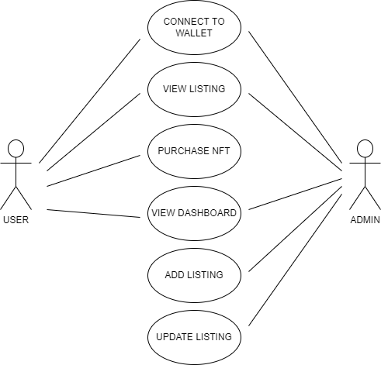

Fig.1 USE CASE DIAGRAM

CHAPTER 3

SOFTWARE DESIGN

3.1 INTRODUCTION

Software design is an engineering process by which we are representing of something that is to be built. It is a blueprint for constructing the software... After making Software Requirement Specification of the project, now we are in position to design the software.

The system design shows how Software will be structured to satisfy the requirements identified during the analysis phase. The design process is a translation of requirements into a description of the software structure, software components, interfaces and data necessary for the implementation phase. The design phase provides a complete blueprint for the implementation activity.

3.2 MODULE DESCRIPTION

,

* Connect Wallet:- In this module, user can connect his/her MetaMask wallet with the website.

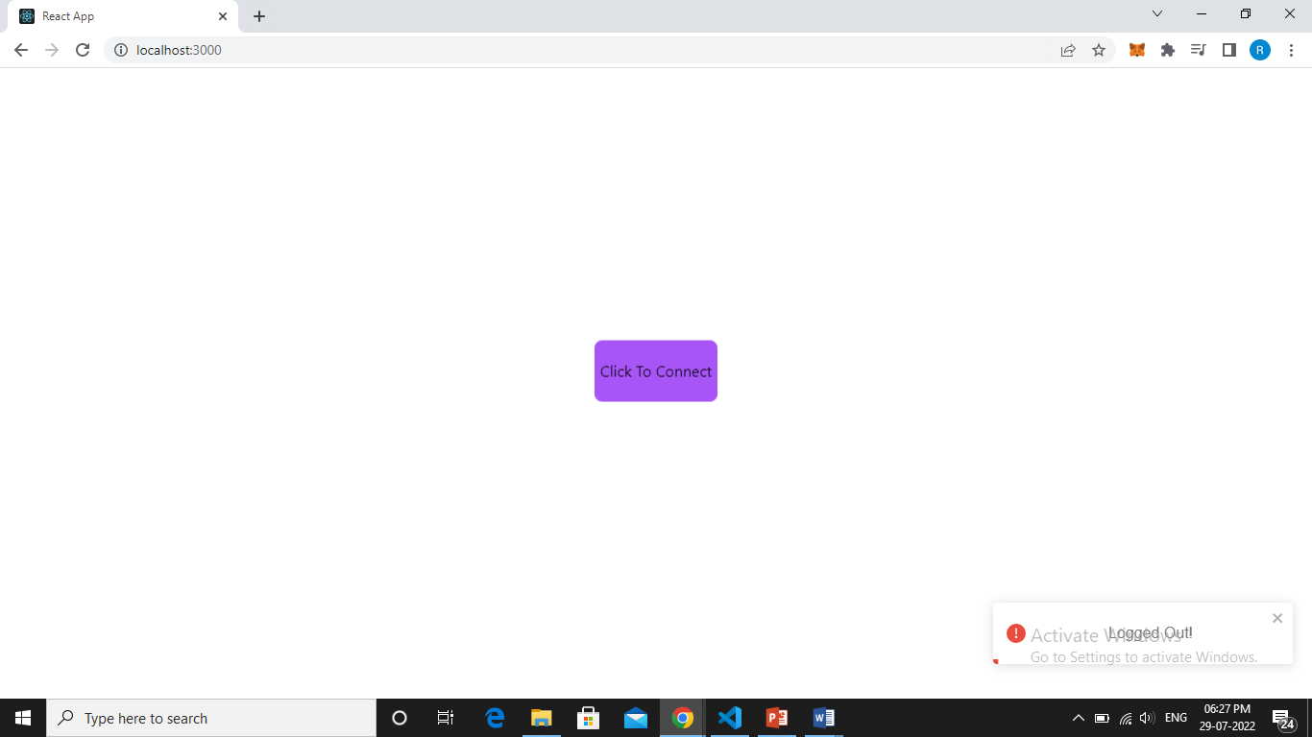

* Listing NFT:- In this module, connected user can see all the active NFT listed in Third Web.

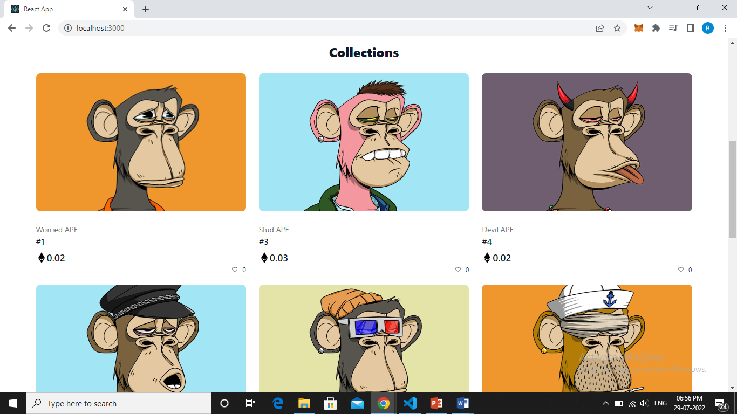

* Purchasing NFT:- In this module, connected user can purchase a NFT which he/she selected.

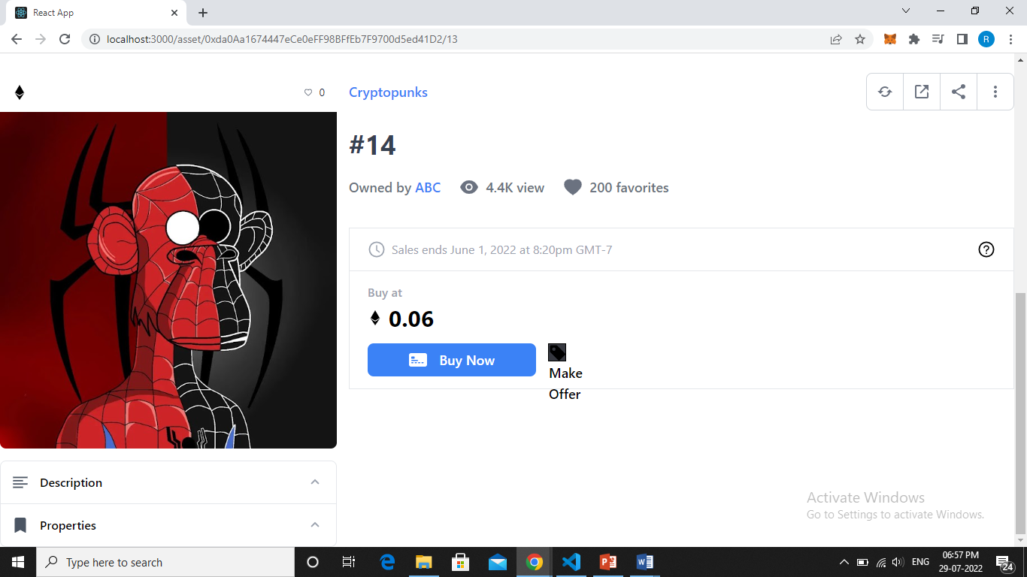

* Dashboard:- In this module, connected user can see all the NFT he/she purchased/owned.

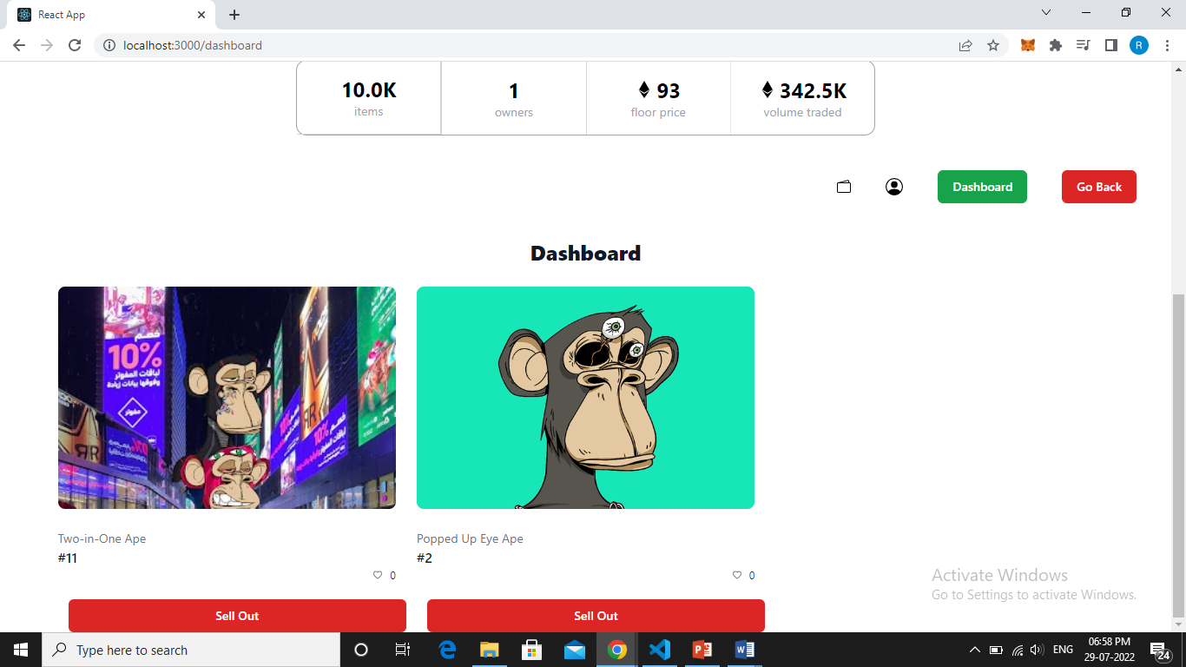

3.3 DATA FLOW DIAGRAM

A Data Flow Diagram (DFD) is a traditional visual representation of the information flows within a system. A neat and clear DFD can depict the right amount of the system requirement graphically. It can be manual, automated, or a combination of both.

It shows how data enters and leaves the system, what changes the information, and where data is stored.

The objective of a DFD is to show the scope and boundaries of a system as a whole. It may be used as a communication tool between a system analyst and any person who plays a part in the order that acts as a starting point for redesigning a system. The DFD is also called as a data flow graph or bubble chart.

* The following observations about DFDs are essential:

1. All names should be unique. This makes it easier to refer to elements in the DFD.
2. Remember that DFD is not a flow chart. Arrows is a flow chart that represents the order of events; arrows in DFD represents flowing data. A DFD does not involve any order of events.
3. Suppress logical decisions. If we ever have the urge to draw a diamond-shaped box in a DFD, suppress that urge! A diamond-shaped box is used in flow charts to represents decision points with multiple exists paths of which the only one is taken. This implies an ordering of events, which makes no sense in a DFD.
4. Do not become bogged down with details. Defer error conditions and error handling until the end of the analysis.

3.3.1 0-LEVEL DFD

A level 0 DFD is called fundamental system model or context model represents entire software element as a single bubble with input and output data indicating by incoming and outgoing arrows. It is also known as fundamental system model, or context diagram represents the entire software requirement as a single bubble with input and output data denoted by incoming and outgoing arrows. Then the system is decomposed and described as a DFD with multiple bubbles.

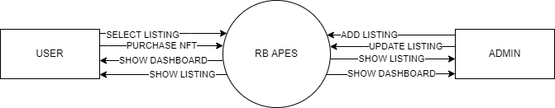

Fig.2 0-Level DFD

3.3.2 1-LEVEL DFD

In 1-level DFD, a context diagram is decomposed into multiple bubbles/processes. In this level, we highlight the main objectives of the system and breakdown the high-level process of 0-level DFD into subprocesses.

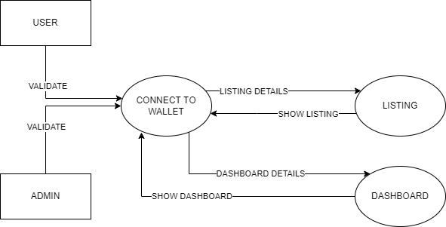

Fig.3 1-Level DFD

3.3.3 2-LEVEL DFD

A level 2 data flow diagram (DFD) offers a more detailed look at the processes that make up an information system than a level 1 DFD does. It can be used to plan or record the specific makeup of a system.

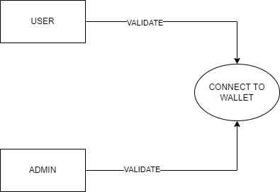

Fig.4.1 Authentication

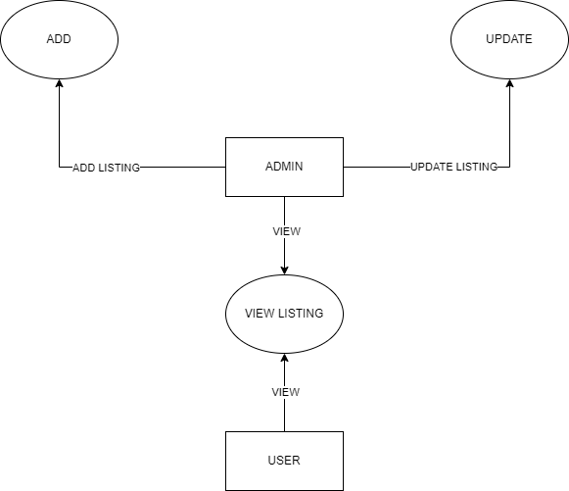

Fig.4.2 Listing

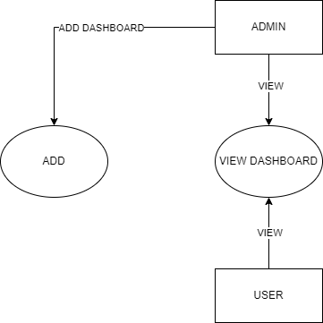

Fig.4.3 Dashboard

CHAPTER 4

TESTING

4.1 INTRODUCTION

Executing a program with the intent of finding errors is called testing. Testing is vital to the success of any system. Testing is done at different stages within the development phase. System testing makes a logical assumption that if all parts of the system are correct, the goals will be achieved successfully. Inadequate testing or no testing at all leads to errors that may come up after a long time when correction would be extremely implementation. The testing of the system was done on both artificial and live data. In order to test data test cases are developed.

4.2 TEST PLANS

The test strategy implementation of the project that defines how the testing has been carried out. We followed the Reactive approach to testing. This means that we continued testing each component or module of our project during its creation. However, we are only able to test it completely once the coding and designing part of the project is complete. The testing methodologies in the development process which make sure that the software can successfully operate in multiple environments and across different platforms. We are trying to develop a project which will work on the web and as a mobile application. This will help the end-users to access the platform with ease and flexibility. Also, the offline mode is available for users to access the network anywhere and anytime.

4.2.1 WHITE BOX TESTING

It is a testing approach in which internal structure is known to the tester. It is best suited for a lower level of testing like Unit Testing, Integration testing. White box testing is usually done by testers and developers. It is a structural test of the software. As developers, we realised that testing through the white-box testing procedure is more feasible than black-box testing because we developed the code and therefore have all the knowledge about the internal structure. The features of white-box testing are in favour of the developers. However, when we learn about other kinds of testing such as non-functional testing, we realise that it is also possible to state some information and facts about them based on our project.

4.2.2 Unit Testing

Unit testing is the first level of testing which ensures that the individual components of a piece of software at the code level are functional and work as they were designed. The unit testing was done during the development of the specific components of each module by an individual. This was conducted manually by repeatedly debugging the errors for the proper functionality of the module components. We typically wrote and aimed to execute the tests prior to the software being deployed in front of the evaluators or testers. This testing helped us debug the code at an early stage so that we don’t find errors when we combine all the components of the module together. E.g., Creation and testing of the login page and forgot password page.

4.2.3 Functional Testing

This testing is based on the requirements specified by various stakeholders and incorporates testing to ensure that all the components are working properly.

4.2.4 Integrating Testing

Integration testing is the next step after unit testing. These are then tested as a group through integration testing to ensure whole segments of an application behave as expected. Once all the components were tested, we began combining those components into one module. Manual tests were also conducted for integration. This test enabled us to run all the components one after the other smoothly. For e.g., creation and testing of the homepage and the subpages individually and then combining it to test it for proper functionality.

4.2.5 SYSTEM TESTING

It is executing programs to check logical changes made in it with intention of finding errors. a system is tested for online response, volume of transaction, recovery from failure etc. System testing is done to ensure that the system satisfies all the user requirements.

4.3 TEST CASES

|  |  |  |  |  |
| --- | --- | --- | --- | --- |
| S.No. | Module Name | Test Case No | Test Case Description | Expected Result |
| 1 | Connect to Wallet | TC1 | To make sure that the system work, user must connect to wallet | Wallet Connected Successfully |
| 2 | Purchase | TC2 | To assure that user can purchase NFT, they must have ETH. | Purchase Successfully |

4.4 TEST REPORT

|  |  |  |  |
| --- | --- | --- | --- |
| **S. No.** | **Test Case No.** | **Test Status** | **Test Report** |
| 1 | TC1 | Successful | Fig 5 |
| 2 | TC2 | Successful | Fig 6 |

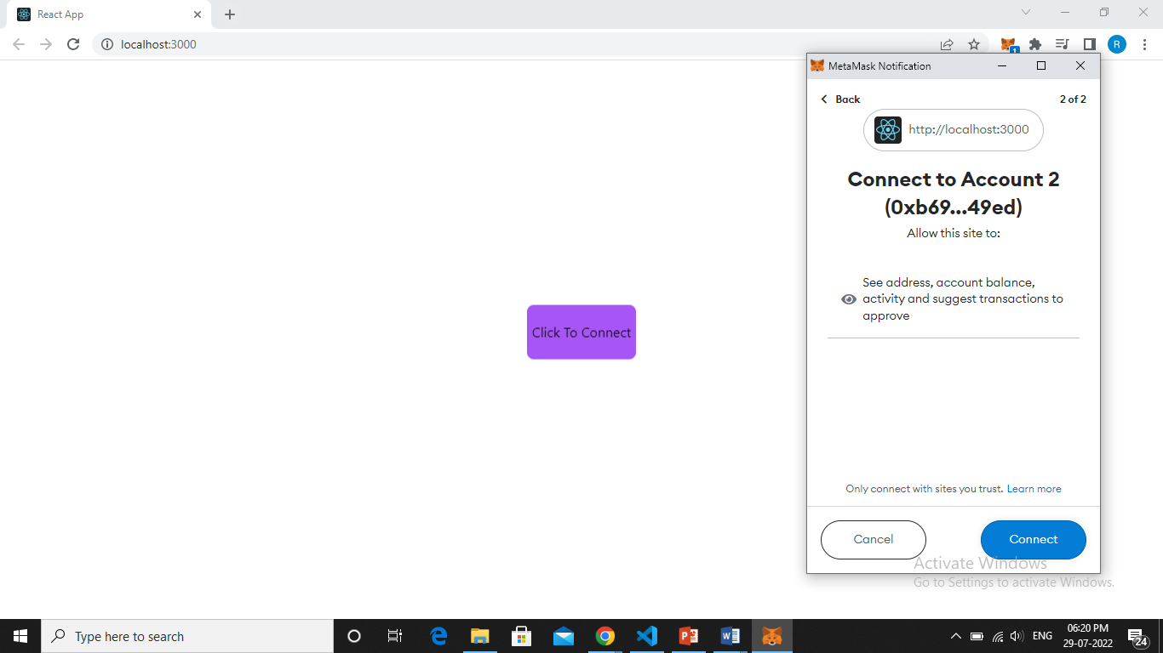

Fig.5 Connect To Wallet Validation

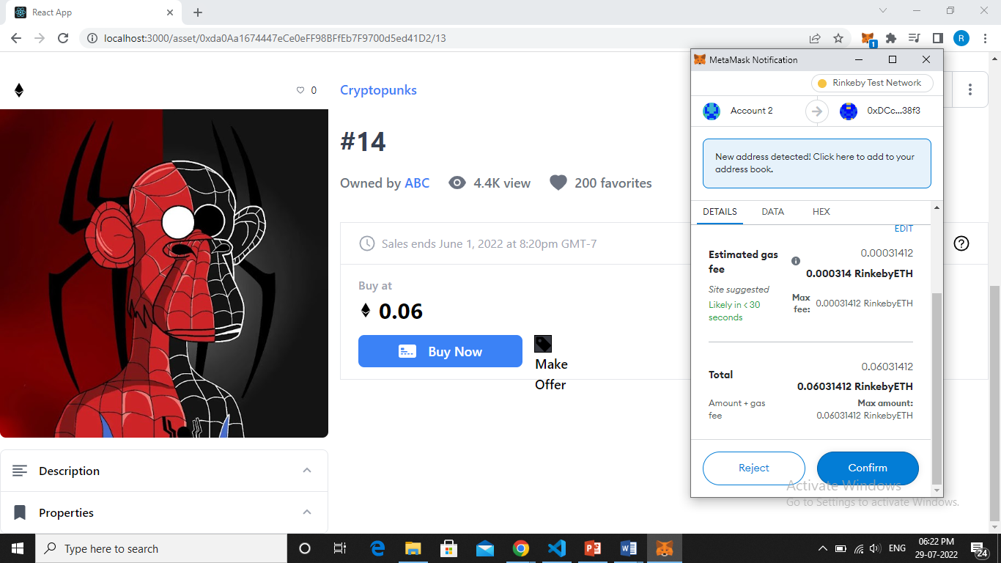

Fig.6 Purchase Validation

CHAPTER 5

ROLES AND RESPONSIBILITIES

5.1 ROLES

While doing my project on RB APES, my responsibilities towards my project are:

* I was involved in collection of information related to my project.
* I have used very easy and user-friendly designing mechanism.
* I am responsible for approving the designing tool.
* Planning and Execution of these page were done by me.
* I am responsible for managing instances of the above-mentioned modules.

5.1 RESPONSIBILITIES

* Work on definition of development requirements and priorities.
* Interfaces with other systems.
* Set up and maintenance of security rights and access permission.
* Contributing to technical strategy, policy and procedure.
* Development and operation of technical testing programmes.
* Production of technical documentation to agreed quality standards.
* Reporting on progress/issues to management and users.

CHAPTER 6

CONCLUSION

NFT marketplaces are yet to see their peak. With the digital versions of different art forms, collectibles, creative assets, and even from the physical world are making waves, the NFT marketplace is a business worth pursuing.

As more people will create, buy, and sell, the popularity of a secure and reliable NFT marketplace will only enhance. The domain is popular but not overcrowded as of now. This presents you with a perfect opportunity and time to launch your own NFT marketplace.

6.1 FUTURE SCOPE

Indeed, the world is changing fast. It is moving away from old- conventional ways of transaction to digitally advanced wallets that make space for both money and crypto currencies. With so many raging possibilities, it’s important to understand the differences between the various types of currencies. **Digital currency is government- issued electronic form of money.**

**Crypto currency**, on the other hand, is a virtual currency created by a private system. It is decentralised, is not governed by any government, and is based on block chain technology. Non-fungible Tokens, or NFTs, are digital assets that represent real-world objects like music, art, **memes**, fashion, and so on.

APPENDICES

**SCREENSHOT**

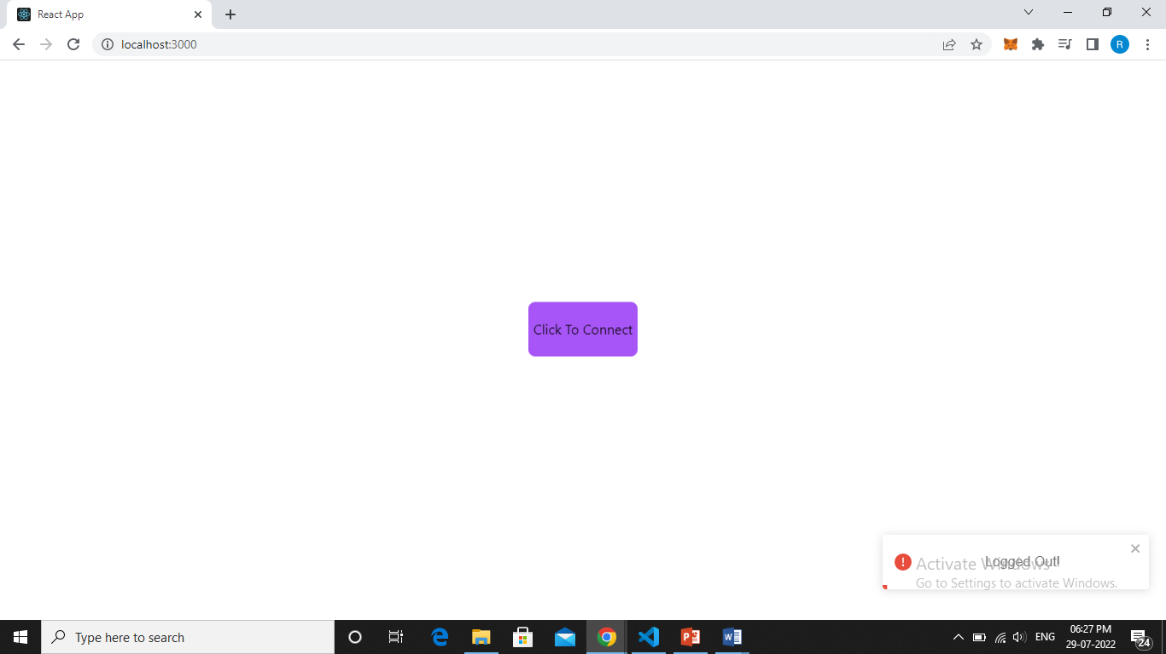

Fig.7 Connect to Wallet Page

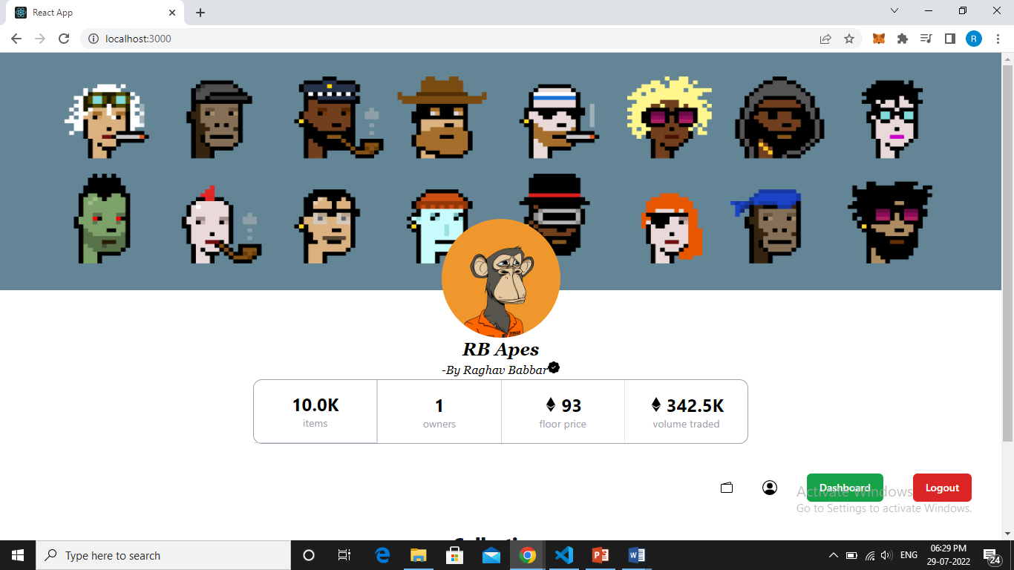

Fig. 8 Front Page

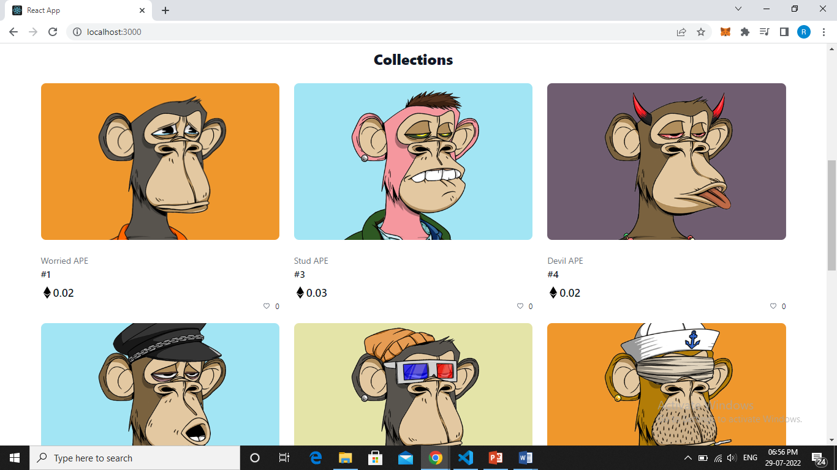

Fig 9 Collection Page

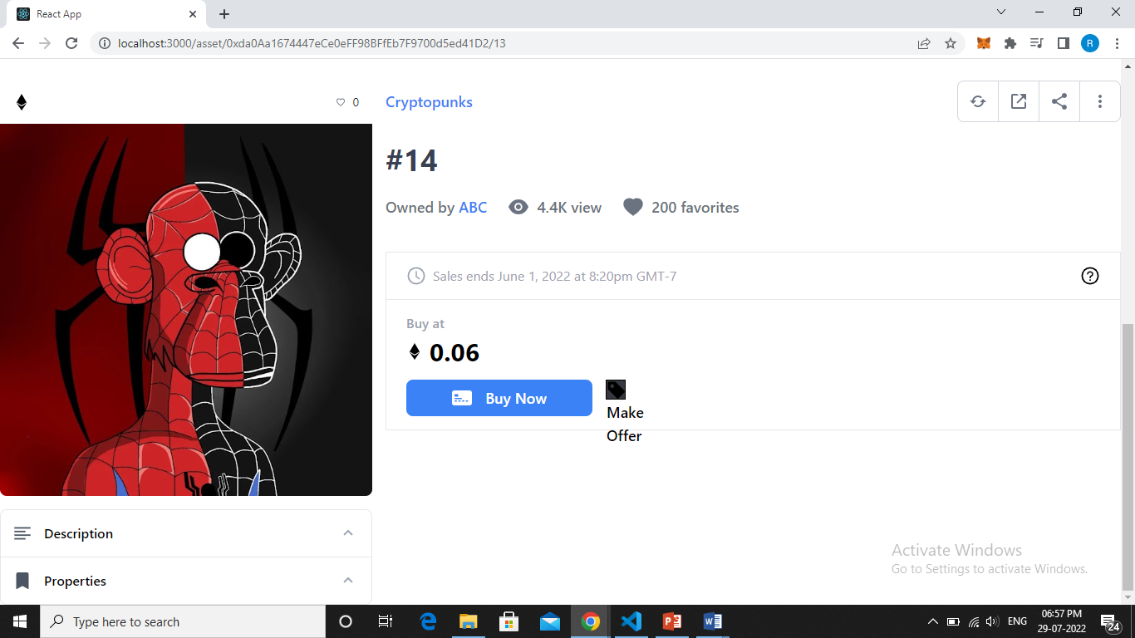

Fig 10 Selected List Page

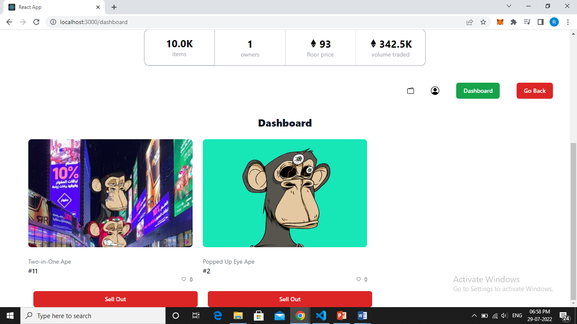

Fig 11 Dashboard Page

REFERENCES

* <https://reactjs.org/docs/getting-started.html>
* <https://reactrouter.com/docs/en/v6/getting-started/overview>
* <https://tailwindcss.com/docs/installation>
* <https://portal.thirdweb.com/>